Market Sector

The Market Sector is divided into three sections: VOC System’s Place in Society, User Demographic, and User Motivation. VOC System’s Place in Society discusses how a VOC monitor will be used with respect to an overall society. User Demographic depicts what kind of users the system is designed and intended for. User Motivation describes what encourages a user to use a VOC monitor system.

VOC System’s Place in Society

VOCs have relatively short atmospheric lifetimes, ranging from a few hours to less than a year.Due to their short lifetimes and vastly varying sources and concentrations it is not plausible to create a global map depicting VOC sources1. With that it is not possible to state what manufacturing processes emit the largest concentration of VOCs.

The Environmental Protection Agency (EPA ) has, however, found it necessary to define a set of standards by which oil refinement companies must adhere to. One of these standards requires that all those in the refinement industry must use ‘green completion’ technology during drilling, or well fracking. What ‘green completion’ means is that a company will use “mobile, trailer-mounted tanks… to capture gases before they escape into the air and route them back into pipelines for sale as natural gas and other valuable chemicals.”2

While David Doniger, of the EPA, asserts in his blog that the majority of leading companies have already begun to adhere to EPA’s standards, there have been countless reports of companies failing to contain the results of oil refinement. This is due, according to the National Oceanic Atmospheric Administration, to companies underestimating their VOC output by an order of one magnitude on average.

An excellent example of such a case occurred in Baton Rouge, Louisiana by Exxon Mobil, a multinational oil and gas corporation. The US Government has sets limits on the amount of air pollution, in pounds, that gas companies can pump into the atmosphere. Through a number of leaks and accidents between 2008 and 2011 Exxon Mobil has dumped over four million pounds of VOCs without government approval, as stated by the Louisiana Department of Environmental Quality. 3

While Exxon Mobil claims that it is safe to live in Standard Heights, the community in which it resides, the locals have reported that the smell of chemicals has been so strong at times that they are forced to leave their homes. Tonga Nolan, Standard Heights resident, reported taking her daughter to the hospital for vomiting profusely the day Exxon discovered a napthan leak. Napthan is a chemical that turns to toxic vapor as it touches the atmosphere.

Exxon Mobil at first claimed that the leak was too small to have effect residents. Months following the company admitted that the leak was much larger than they originally thought but residents never received an official statement, apology, or compensation for the incident. 3

While the EPA and the Government has set rules and regulations for companies whom produce and manufacture VOC’s it is not enough to keep communities safe. The oil and gas industry has not taken on the responsibility of setting up alert systems in case of accidents. Methods that companies use to measure VOCs have been proven to be invalid. Gas is a multibillion dollar industry that small communities cannot stand up again in court due to insufficient evidence and funds.

The VOC Monitoring System by Sentient is a cheap means for residents to have peace of mind due to its alert system. All VOC levels are recorded along with a time and location stamp. If a leak did occur, the monitor’s data could be used in court in order to prove that VOCs traveled far enough and in a high enough concentration to effect surrounding populations.

The VOC monitors place in society falls with the general population as a means to protect and defend themselves from both accidents and the negligence of VOC manufacturing companies.

User Demographic

During the Naphlan leak by Exxon Mobil, two EPA representatives were visiting the plant. The EPA was in Standard Heights to interview residents that live close to Exxon Mobil. The effort was part of a study being conducted by the EPA to uncover an unfair fact: “people who live near big pollution plants tend to have lower incomes.”3

Environmental Health Sciences (EHS) takes the claim home with the following image of North Richmond, California. The imagine uses a key guide to show where the five oil refineries, three chemical plants, and eight Superfund sites are located. The color index takes into consideration the distance from these sites, income, and race of residents in Richmond.

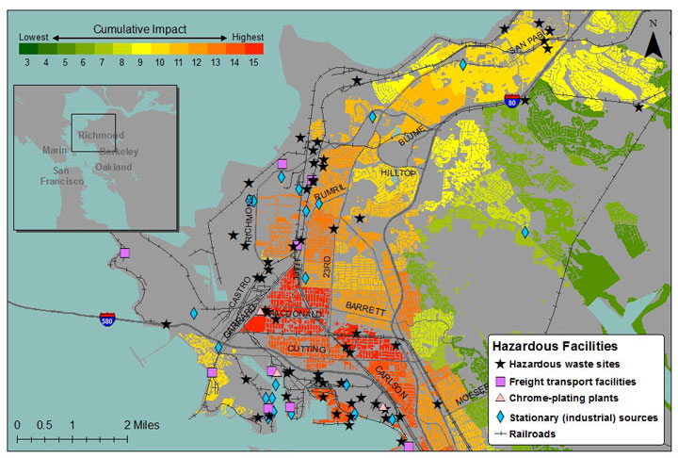

Map courtesy of Rachel Morello-Frosch (University of California, Berkeley), James Sadd (Occidental College), Manuel Pastor and   
Justin Scoggins (University of Southern California)

It is clear that the value of land is drastically reduced by the nearby presence of VOC emitters. Henry Clark, a longtime resident of North Richmond, recalled being a child in his home town and the air being so foul at times that he’d have to plug his nose and wait inside until the emissions cleared up. He jokes that the cheapest housing shared a fence with the Chevron oil refinery.

What residents think they are saving in cheap rent; they are actually trading their health for. There is a surmount of evidence that those who are most in danger of VOC exposure are low income families. The Department of Education has also released reports stating that low income often correlates to less education and health awareness.4 Low income communities are also less able to defend themselves against multibillion dollar companies like Chevron.

For these reasons the user demographic of our system consists of low income, limited education communities that border VOC manufacturers. The nature of the VOC Monitor, however, allows for use in wealthier communities that have a lower risk of VOC exposure. While the user demographic can be expanded, this system’s design focuses on low income communities.

User Motivation

During his excerpt with the EHS Clark summed up his experience to “nobody came to check on the health in North Richmond.” 3 His quote directly addresses the user motivation behind the system. In North Richmond it is up to the community itself to address the issue of VOC pollution. In fact, even when the correlation between air quality and property value is not as black and white as is in Richmond, low income communities are still left to fend for themselves.

Even with residents simultaneously complaining of strong chemicals smells and vomiting, Exxon Mobil ignored and downplayed the extent of a VOC leak. Even after Exxon Mobil admitted that the spill was much grander than they originally believed, they still did not offer compensation or issue an apology for the incident. Even after countless leaks and accidents from 2008 to 2011, Exxon has not implemented a warning system in Standard Heights.3

The EPA has already set tight standards for VOC emitters. The Government has already set limits on the number of pounds companies can release into the atmosphere.2 If the community does not come together to put in their own VOC Monitoring system, if they do not have sufficient evidence of VOC emissions, then nothing will change. The motivations behind the users of the Sentient VOC Monitoring system is that it is affordable, easy to implement, and their answer to a very serious issue.

References

1. Doniger, David. “ David Doniger Blog”. *Leading Companies Already Meets EPA Fracking Air Pollution Standards*. SwitchBoard, 18 April 2012. Web. 15 Nov. 2013.

<http://switchboard.nrdc.org/blogs/ddoniger/leading_companies_already_meet.html>

2. National Center For Education Statistics. “Income of Young Adults”. *The Condition of Education 2013. 2013. Web. 15 Nov. 2013.*

<http://www.npr.org/2013/05/30/187044721/baton-rouge-s-corroded-overpolluting-neighbor-exxon>

1. Kay, Jane. Katz, Cherly. “Environmental Health News”. *Pollution, Poverty, People of Color: The factory on the hill.* 4 June 2012. Web. 15 Nov. 2013.

<http://www.environmentalhealthnews.org/ehs/news/2012/pollution-poverty-and-people-of-color-richmond-day-1>

1. Shogren, Elizabeth. Benincasa, Robert. “Poisoned Places: toxic air, neglected communities”. Baton Rouge’s Corroded, Overpolluting Neightbor: Exxon Mobil. 30 May 2013. Web. Nov 15 2013. <http://nces.ed.gov/fastfacts/display.asp?id=77>